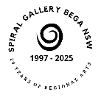
SPIRAL GALLERY
NEWSLETTER January - June 2026

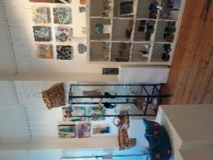
28 November 2025 – 13 January 2026 gallery 1
Artesanato

Spiral Gallery's Artists & South Coast artists’ annual Cash, Card & Carry - a smorgasbord of original artworks for the summer season: ceramics, jewellery, clothing, prints, paintings, handcrafted wood & knives, baskets, glassware & more.

29 December 2025 – 13 January 2026 gallery 2
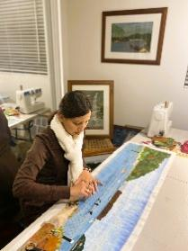
Whispers Through Fabric: Issara
Rooted in a childhood immersed in dressmaking & handcraft, Issara’s practice embraces the improvisational nature of textile work. The pieces evolve through touch, memory, & slow, meditative construction. Using her own eco-printed fabrics made from leaves & flowers in her garden, she aims to create quiet, emotionally resonant works that honour both personal & ecological histories.

16 January – 11 February gallery 1
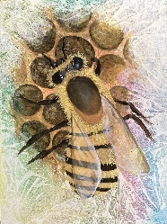
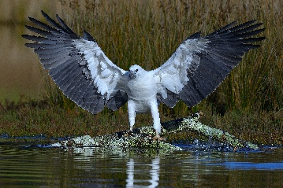
Nature’s Palette –
Alex Bell & Helen Morris
Showcasing the natural beauty of landscape, flora & fauna in our south east region of NSW. An eclectic mix of photography, drawing, print & paint.

13 February – 11 March gallery 1
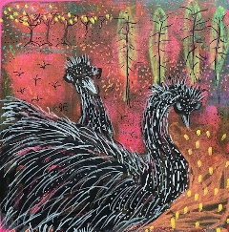
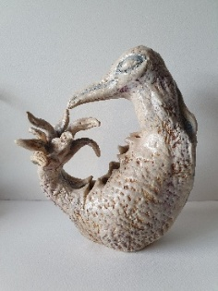
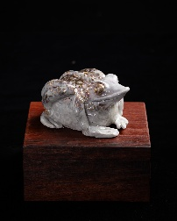
Creatures:
Anneke Paijmans
Ivana Gattegno
& Joy Georgeson
These artists work in the bush en plein air & in their studios to make their art. Observations & imaginations create a mix of realistic representations & imaginary ‘Creatures’

13 March – 14 April gallery 1
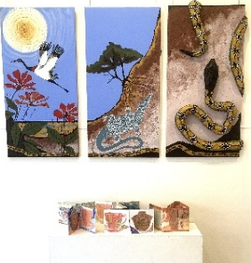
Spiral Members & South Coast Artists

An exhibition of the many & varied talents & skills of Spiral Gallery Co-operative Members & other South Coast artists with ceramics, sculpture, basket weaving, jewellery, woodwork, textiles, paintings & more.

13 – 31 March gallery 2
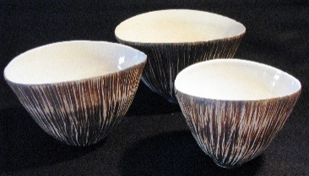
Sixes & Sevens –
Sharon Cornthwaite, Sonja Jacob,
Deborah Barret & Ann Jackson

The works will be a mix of small sculptures, ceramics, mixed media wall works, textiles, lights & jewellery.

1 – 14 April gallery 2
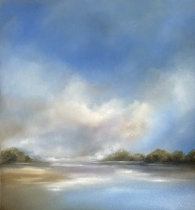
Echoes on the Lake – Jane Murphy solo

For the last decade Jane has had a close connection with Merimbula’s Top Lake. It is her inspiration for this exhibition, focusing on the cloud formations reflected into the lake & shore line. This body of work combines peaceful dream-like oil paintings with small sculptures of found objects from the shore line.

17 April - 13 May gallery 1
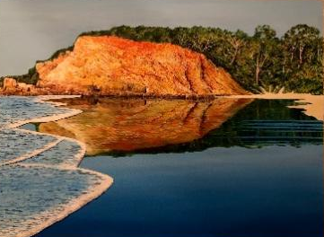
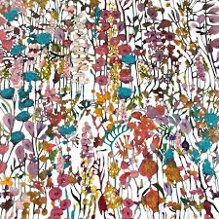
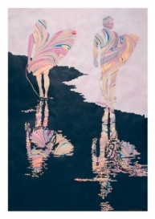
Naturally Connected –
Peter Otton,Rachael Vogelzang & Phoebe Bakker

Peter & Rachael feature light, reflections & the motion of water as their subject & the contemplative state that comes from being in or near large bodies of water. Phoebe focuses on the patterns & colour of plants, both soothing & a riot of colour.

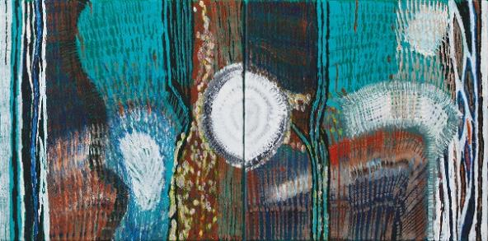
15 May – 10 June gallery 1


Celebrating First Nations artists living on Yuin Country
Featuring Indigenous artists living on Yuin Country. A celebration of Indigenous culture. Presented with the financial assistance of South East Arts & Indigenous Visual Arts Industry Scheme.

12 June – 7 July gallery 1
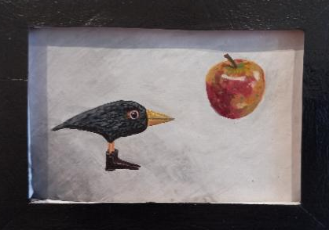
A Plethora of Postcards

YOU are invited to CREATE A6-sized artworks & enter them in the 15th annual Plethora of Postcards Exhibition. Submit up to ten postcards, any medium, with 2D & 3D entries encouraged. Just do not miss out on YOUR OPPORTUNITY to be part of this very popular show & amaze yourself, your friends & family. Great prizes to be won in several categories.

Email the Postcard Team for an Entry Form: spiralpostcards@gmail.com
Entry forms will be available on the Spiral Gallery website from mid April.

Exhibition proposals welcome for 2027
If you would like to apply for an exhibition at Spiral Gallery, please email your proposal, CV or artist statement, & recent images of work to Spiral Exhibition Co-ordinator: nancyjbrunton@gmail.com

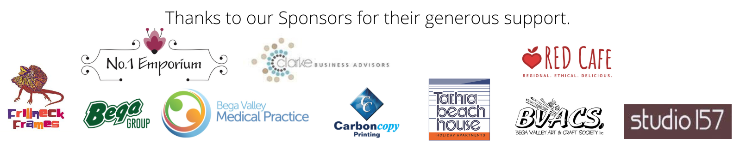

SPIRAL GALLERY 47 CHURCH STREET BEGA 2550 02 6492 5322
www.spiralgallery.org.au Open Mon-Fri 10-4 Sat 10-1

